TOGAF® Template – Architecture Building Blocks
Version 2.0
July 2024
Project XXXX
Client YYYY
Note: This document provides a generic template. It may require tailoring to suit a specific client and project situation.
Document Version History
Version  Number | Version  Date | Revised By | Description | Filename

Contents
1. Purpose of this Document 4
1.1 Building Blocks Process 4
2. Building Blocks 5
2.1 Fundamental Functionality 5
2.2 Attributes 5
2.3 Semantic 5
2.4 Security Capability 5
2.5 Manageability 5
3. Interfaces 6
3.1 Overview 6
3.2 Interoperability 6
3.3 Dependent Building Blocks 6
4. Mapping 7
4.1 Mapping to Business/Organizational Entities 7
1.1 Mapping to Business/Organizational Policies 7
Tracking Information
Project Name | Project XXX
Prepared By |  | Document Version No.
Title | Architecture Building Blocks | Document Version Date
Reviewed By |  | Review Date
Distribution List
From | Date | Phone/Email

To | Action* | Due Date | Phone/Email
* Action Types: Approve, Review, Inform, File, Action Required, Attend Meeting, Other (please specify)

Purpose of this Document
Architecture Building Blocks (ABBs) relate to the Architecture Continuum (see Architecture Continuum), and are defined or selected as a result of the application of the Architecture Development Method (ADM).
Characteristics are:
- Capture architecture requirements; e.g., Business, Data, Application, and Technology requirements
- Direct and guide the development of SBBs

Building Blocks Process
The process of building block definition takes place gradually as the ADM is followed, mainly in Phases A, B, C, and D. It is an evolutionary and iterative process because as definition proceeds, detailed information about the functionality required, the constraints imposed on the architecture, and the availability of products may affect the choice and the content of building blocks.
The key phases and steps of the ADM at which building blocks are evolved and specified are summarized in the following figure. The major work in these steps consists of identifying the ABBs required to meet the business goals and objectives. The selected set of ABBs is then refined in an iterative process to arrive at a set of SBBs which can either be bought off-the-shelf or custom developed.
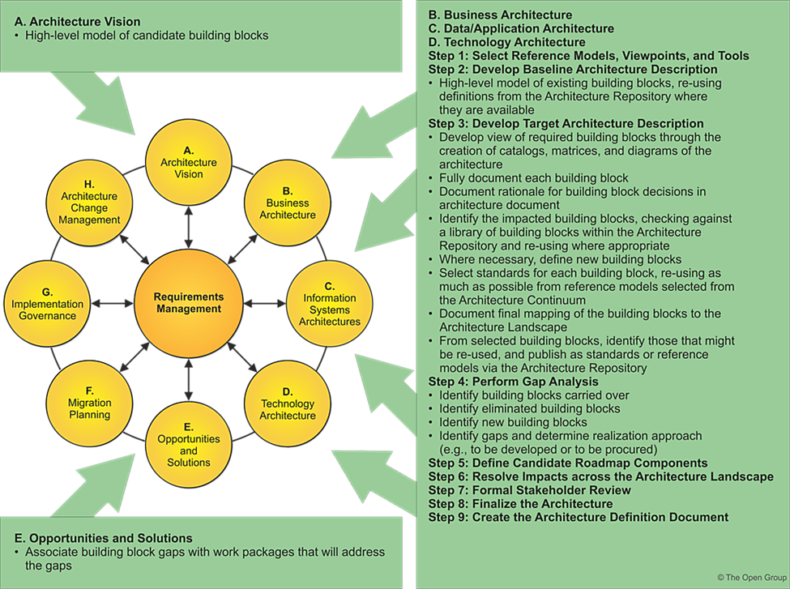

Building Blocks
The purpose of this section is to outline fundamental functionality and attributes: semantic, unambiguous, including security capability and manageability.

Fundamental Functionality

Attributes

Semantic

Security Capability

Manageability

Interfaces
Interfaces: chosen set, supplied.

Overview

Interoperability
Interoperability and relationship with other building blocks.

Dependent Building Blocks
Describe dependent building blocks with required functionality and named user interfaces.

Mapping
Map to business/organizational entities and policies.

Mapping to Business/Organizational Entities
The purpose of this section is to cross-reference the building blocks to the business/organizational entities.
Mandatory/optional: This section is mandatory.

Mapping to Business/Organizational Policies
- The purpose of this section is to cross-reference the building blocks to the business/organizational policies
Mandatory/optional: This section is mandatory

